Thermistor

One potential option is NTC Thermistors. Data Sheet with temperature data and expected resistance found at: http://www.vishay.com/docs/29049/ntcle100.pdf

This temperature varying resistor will be used to measure the temperature on Mars.

This thermistor will need to be put into a voltage divider circuit in order to measure the voltage drop over it. It would be prudent to put this into a voltage follower buffer in order to ensure that the ADC does not accidentally mess up the results of the voltage divider giving us incorrect values and skewing our data. The following circuit would be what we would do to condition the circuit.

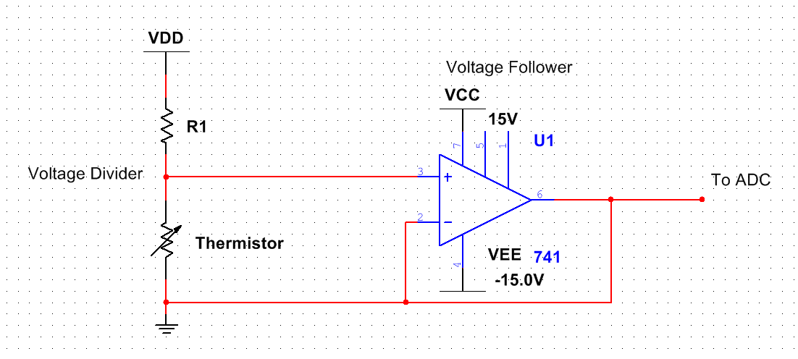

Figure 1: Thermistor Circuit

If supply voltage for the voltage divider is unable to provide a valid ADC voltage range the signal may need to be amplified by using two inverting amplifiers feeding into one another like the circuit shown below as Vs. This will likely not need the voltage follower in this case. The gain of this system will have to be calculated to work with the positive and negative rails of our ADC using the formula shown in Figure 3.

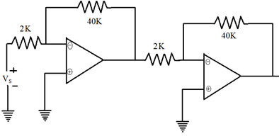

Figure 2: Example of Cascading Inverting Amplifiers

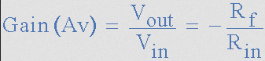

Figure 3: Inverting Amplifier Gain Formula

The actual code for turning these voltages into usable data will need a lookup table with the data found in the datasheet for getting temperatures from specific resistances.